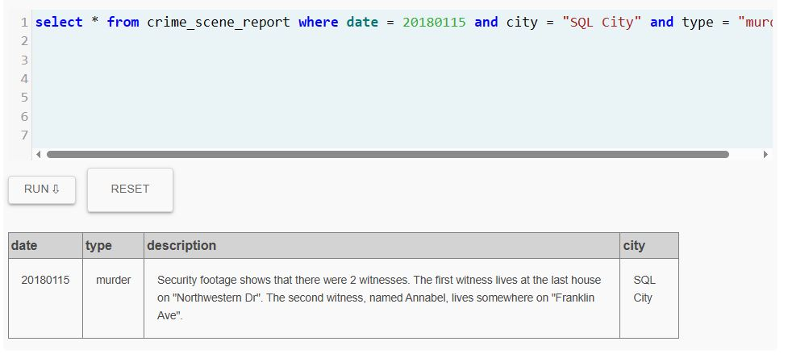
Used this to find the murder description

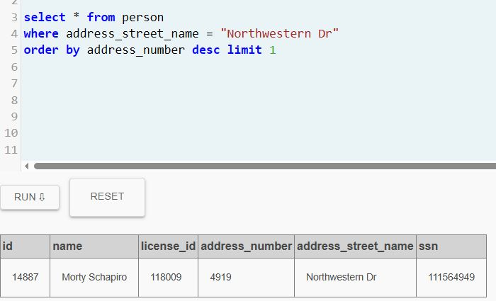

Found who lives at the highest number house on Northwestern dr.

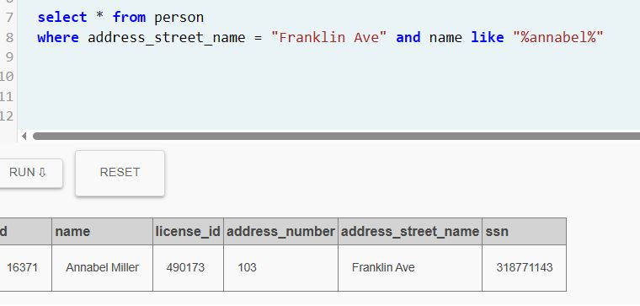

Found who lives on Franklin Ave with the name Annabel

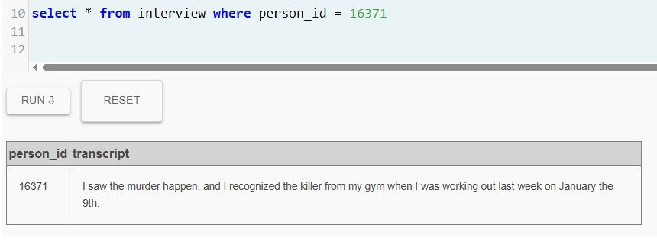
Annabels interrogation
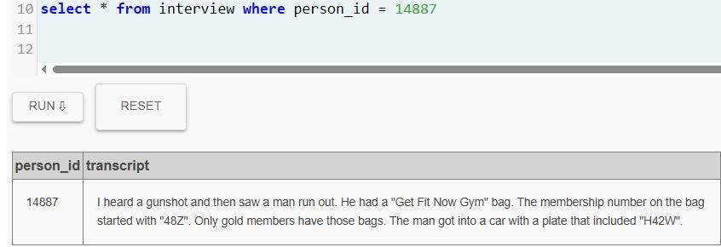
Morty’s interrogation
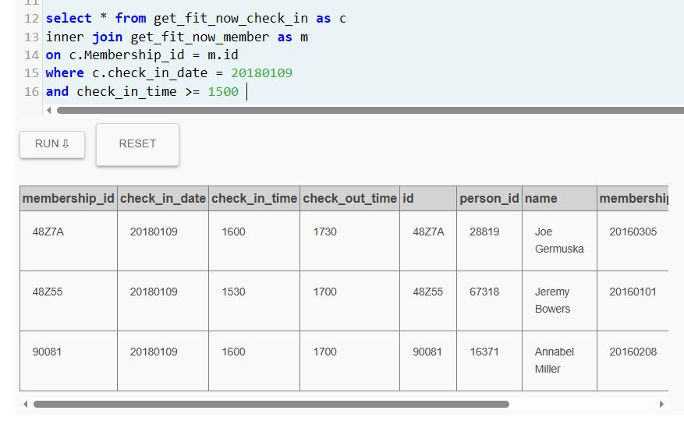
Found the people in the gym at the same time as Annabel on Jan 9th
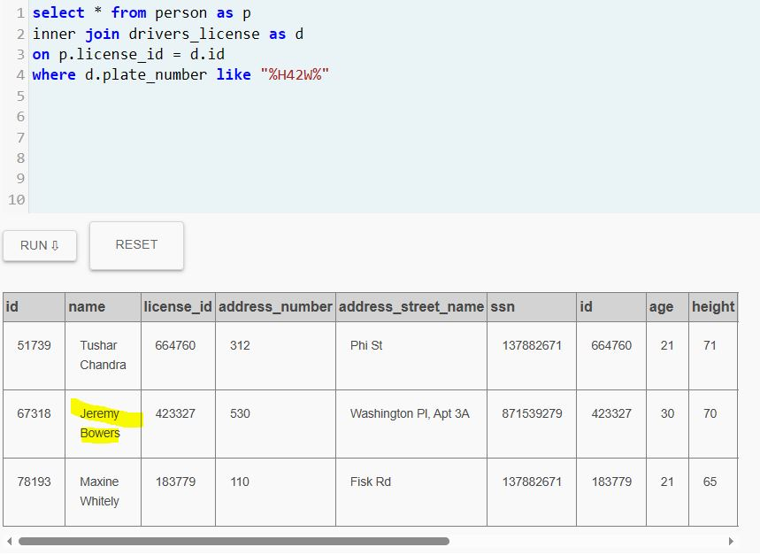
Found Jeremy Bowers who matches all criteria
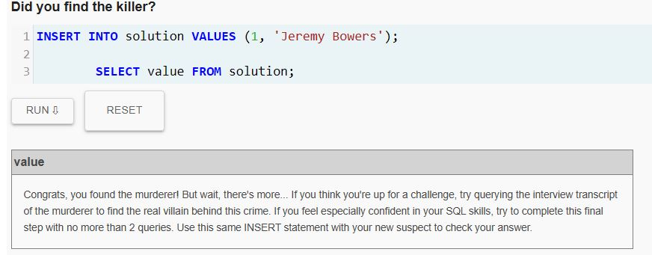
Looked for the mastermind by getting Jeremy’s interrogation
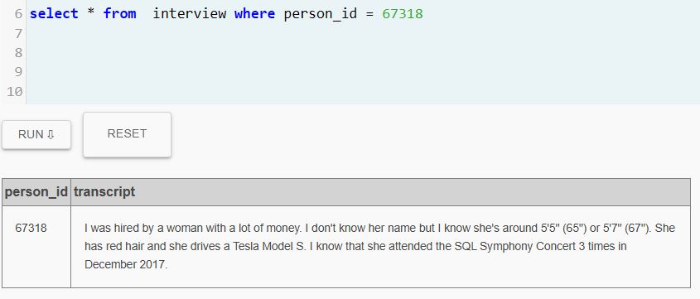
I forgot to capture it but i found the man and woman who had attended the symphony 3 times in Dec 2017, picked the woman, got her ssn, she made $300k+ a year as well as meeting the physical descriptors.
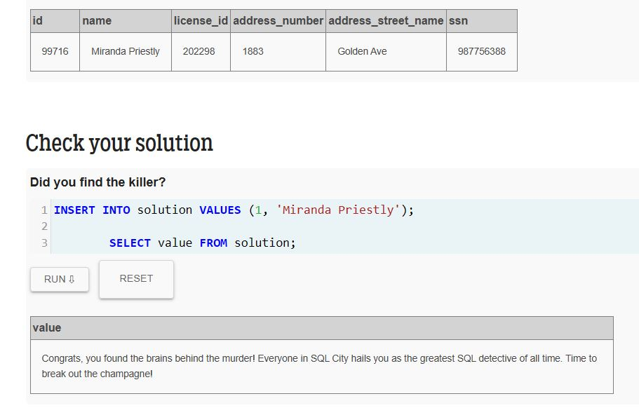
Mystery solved Miranda Priestly

